Teaching Teamwork is a [NSF ATE funded project](https://www.nsf.gov/awardsearch/showAward?AWD_ID=1400545&HistoricalAwards=false) to help to teach students of electronics how to work effectively in teams. We monitored students’ actions as they work together, analyze the data produced, and report on the performance of each individual student, as well as that of the team as a whole. Analysis is informed by various learning sciences frameworks through data mining to describe sequential sequential interactions of the data from teams captured. The data comprise actions, such as the modification of a circuit, measurements made with simulated test equipment, and written or oral communications. Patterns of actions are found that serve as markers for effective collaboration. This project yielded information regarding effective methods to assess both individual and team effectiveness for students participating in online collaborative laboratories. The information learned can apply to the teaching and assessment of collaborative problem-solving skills generally and are not restricted to the field of electronics. Check out the [Teaching Teamwork Live System](https://teaching-teamwork.concord.org/breadboard/#three-resistors-level1).

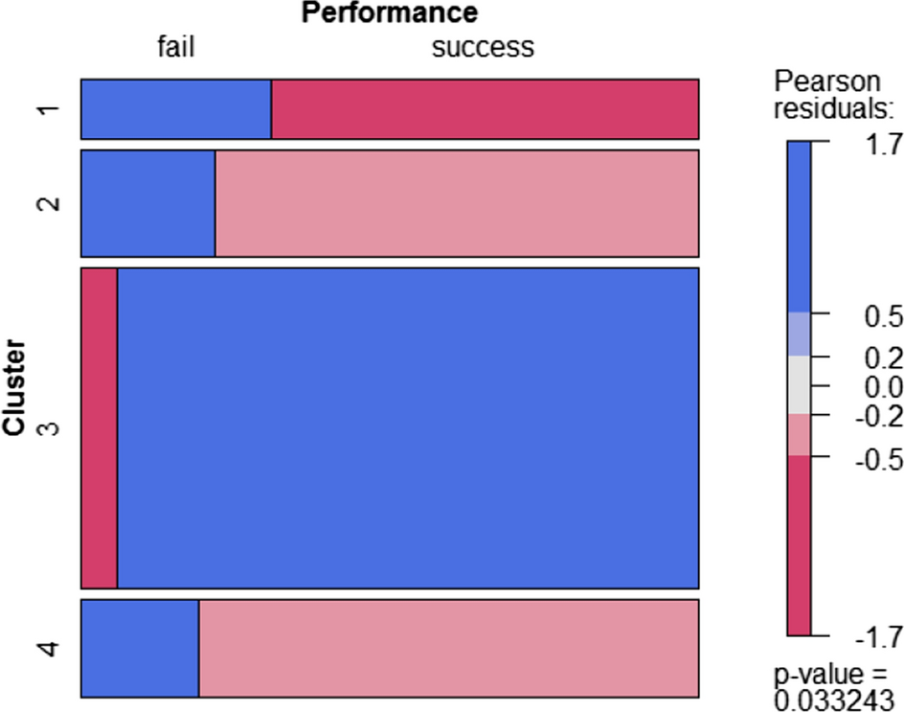

Relevant Publications

<https://www.sciencedirect.com/science/article/abs/pii/S0360131519300636>

<https://www.sciencedirect.com/science/article/abs/pii/S0747563219301700>

<https://www.sciencedirect.com/science/article/abs/pii/S1096751618304512>

<https://link.springer.com/article/10.1007/s12528-022-09318-1>